B. M. S College of Engineering
BULL TEMPLE ROAD, BANGALORE - 560019

DEPARTMENT OF COMPUTER SCIENCE AND ENGINEERING

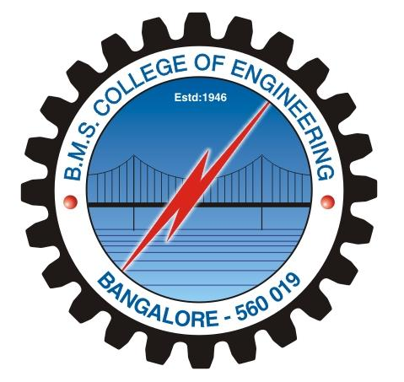

CERTIFICATE

This is to certify that Mr. ABHISHEK AGRAWAL , USN:1BM12CS003 and Mr. ANKUR KARMACHARYA , USN:1BM12CS012 have satisfactorily completed the course of experiments in System Software laboratory on TEXT EDITOR for Vth semester COMPUTER SCIENCE AND ENGINEERING course for the academic year 2014-2015.

…………………………….. ………………………………….
Head of the department Staff in-charge of the batch

Date: …………………..

MARKS OBTAINED
MAX MARKS | MARKS OBATINED
…………………………………
(ABHISHEK AGRAWAL,
USN: 1BM12CS003)

…………………………………..
(ANKUR KARMACHARYA,
USN: 1BM12CS012)

BMS COLLEGE OF ENGINEERING
(Autonomous college under VTU)
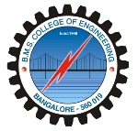
DEPARTMENT OF COMPUTER SCIENCE AND ENGINEERING

A System Software Project Report on
TEXT EDITOR
By
Abhishek Agrawal (1BM12CS003)
Ankur Karmacharya (1BM12CS012)

Under the guidance of professors
Mr.Vikranth B.M
Mr. Lohith J J
Department of CSE.

(Academic year 2014-2015)

